Chapter 12, Problem 56.

Using Fig. 12.63, design a problem to help other students to better understand unbalanced three-phase systems.

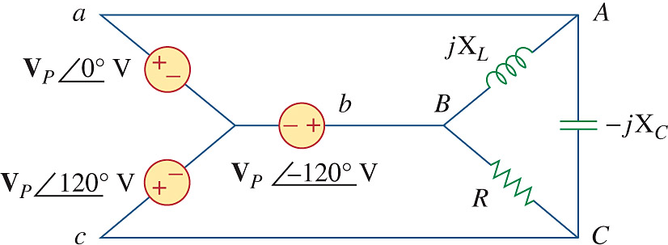

Figure 12.63
For Prob. 12.56.

